**Assignment-4**

| Assignment Date | 30 October 2022 |
| --- | --- |
| Student Name | Mr.R.Vinayaga moorthy |
| Student Roll Number | AC19UCS138 |
| Maximum Marks | 2 Marks |

**Write code and connections in wokwi for ultrasonic sensors. Whenever distance is less than 100 cms send "alert" to ibm cloud and display in device recent events.**

**PROGRAM:**

#include <WiFi.h>

#include <PubSubClient.h>

void callback(char* subscribe topic,byte* payload, unsigned int payloadLength);

#define ORG "fdd82r"

#define DEVICE_TYPE "Pi"

#define DEVICE_ID "123"

#define TOKEN "12345678"

String data3;

char server[]= ORG ".messaging.internetofthings.ibmcloud.com";

char publishTopic[]="iot-2/evt/distance/fmt/json";

char subscribeTopic[]="iot-2/cmd/test/fmt/String";

char authMethod[]="use-token-auth";

char token[]=TOKEN;

char clientID[]="d:"ORG":"DEVICE_TYPE":"DEVICE_ID;

WiFiClient wifiClient;

PubSubClient client(server,1883,callback,wifiClient);

#define ECHO_PIN 2

#define TRIG_PIN 4

#define led 5

void setup() {

// put your setup code here, to run once:

Serial.begin(115200);

pinMode(led, OUTPUT);

pinMode(TRIG_PIN, OUTPUT);

pinMode(ECHO_PIN, INPUT);

wifi connect();

mqtt connect();

}

float readDistanceCM() {

digitalWrite(TRIG_PIN, LOW);

delayMicroseconds(2);

digitalWrite(TRIG_PIN, HIGH);

delayMicroseconds(10);

digitalWrite(TRIG_PIN, LOW);

int duration=random(1,200);

//Serial.println(duration);

//duration = pulseIn(ECHO_PIN, HIGH);

return duration ;

//Serial.println(duration);

}

void loop() {

float distance = readDistanceCM();

//Serial.println(distance);

bool isNearby = distance < 100;

digitalWrite(led, isNearby);

Serial.print("Measured distance: ");

Serial.println(distance);

if(distance<100){

PublishData2(distance);

}else{

PublishData1(distance);

}

//PublishData(distance);

delay(1000);

if(!client.loop()){

mqttconnect();

}

//delay(2000);

}

void PublishData1(float dist){

mqttconnect();

String payload= "{\"distance\":";

payload += dist;

payload+="}";

Serial.print("Sending payload:");

Serial.println(payload);

if(client.publish(publishTopic,(char*)payload.c_str())){

Serial.println("publish ok");

} else{

Serial.println("publish failed");

}

}

void PublishData2(float dist){

mqttconnect();

String payload= "{\"ALERT\":";

payload += dist;

payload+="}";

Serial.print("Sending payload:");

Serial.println(payload);

if(client.publish(publishTopic,(char*)payload.c_str())){

Serial.println("publish ok");

} else{

Serial.println("publish failed");

}

}

void mqttconnect(){

if(!client.connected()){

Serial.print("Reconnecting to ");

Serial.println(server);

while(!!!client.connect(clientID, authMethod, token)){

Serial.print(".");

delay(500);

}

initManagedDevice();

Serial.println();

}

}

void wificonnect(){

Serial.println();

Serial.print("Connecting to");

WiFi.begin("Wokwi-GUEST","",6);

while(WiFi.status()!=WL_CONNECTED){

delay(500);

Serial.print(".");

}

Serial.println("");

Serial.println("WIFI CONNECTED");

Serial.println("IP address:");

Serial.println(WiFi.localIP());

}

void initManagedDevice(){

if(client.subscribe(subscribeTopic)){

Serial.println((subscribeTopic));

Serial.println("subscribe to cmd ok");

}else{

Serial.println("subscribe to cmd failed");

}

}

void callback(char* subscribeTopic, byte* payload, unsigned int payloadLength){

Serial.print("callback invoked for topic:");

Serial.println(subscribeTopic);

for(int i=0; i<payloadLength; i++){

data3 += (char)payload[i];

}

Serial.println("data:"+ data3);

if(data3=="lighton"){

Serial.println(data3);

digitalWrite(led,HIGH);

}else{

Serial.println(data3);

digitalWrite(led,LOW);

}

data3="";

}

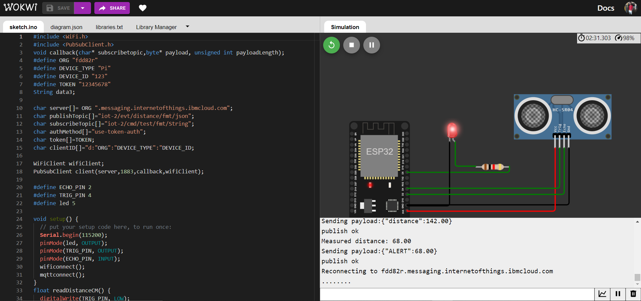

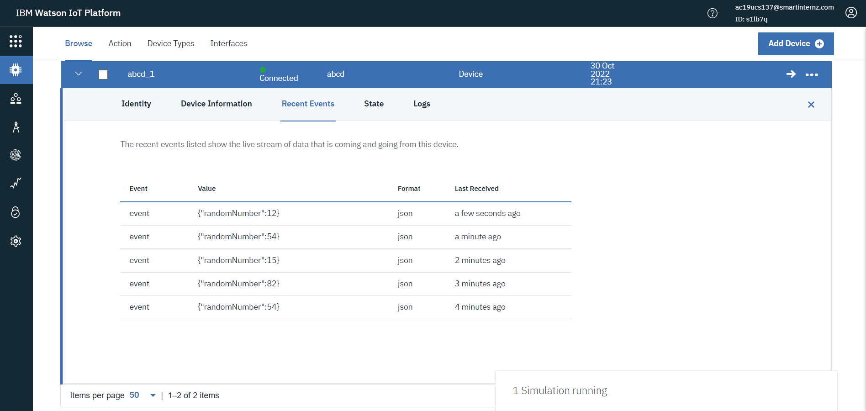

REFERENCE: https://wokwi.com/projects/346961481041969746